LANDIS-II

Forest Product Sector Module (FPSM)
Version 1.0

User’s Guide

Caren C. Dymond, Sarah Beukema and Donald C.E. Robinson
Last Revised: Nov 25, 2025

1. The Extension 3
1.1. Overview 3
1.2. Harvest To Primary Products 5
1.3. Mills to Primary Wood Products 6
1.4. Primary Products to Markets 6
1.5. Primary Products to Secondary Products 6
1.6. Secondary Product Retirement 8
1.7. Disposal 8
1.8. Respiration Rules & Landfill Gas Management 9
1.9. Substitution 10
1.10. References 11
1.11. Acknowledgments 11
2. Main Input Configuration File 12
2.1. Header 12
2.2. Input Files 12
2.3. Species Group Table 13
2.4. Forest to Mills 13
2.5. Mill To Primary 14
2.6. Primary Products to Markets 14
2.7. Primary to Secondary 15
2.8. Secondary to Retirement 16
2.9. Disposal 17
2.10. Substitution 18
2.11. Landfill Gas Management 18
3. Sample Main Input File 20
4. Input Files from FORCS 23
4.1. log_FluxBio.csv 23
4.2. log_FluxDOM.csv 24
5. Output 25
5.1. FPS_log.txt 25
5.2. FPS_test_out.csv 26
5.3. FPS_raw_out.csv 27

The Extension

This document describes the Forest Products Sector Module (FPSM) for the LANDIS-II model. This version is designed to work with output from the Forest Carbon Succession (ForCS) extension (Dymond et al. 2021). For information about the LANDIS-II model and its core concepts including succession, see the LANDIS-II Conceptual Model Description (https://drive.google.com/file/d/15gSueug-Rj9I2RZqdroDbad-k53Jq7j3/view?usp=sharing). However, it can process any harvested carbon information that is presented in the appropriate file format, see Section 4.

The installer creates a directory called FPS on your C: drive. The LANDIS-II components are provided in the package for non-Landis users.

This module is designed to take harvested carbon and track it through several processing steps. Each step moves carbon between different product or waste pools and reports output. The extension allows users to see how much C is stored in forest products over time, as well as the resulting emissions.

While the number of processing steps is fixed, the complexity and the details in each is largely user defined and will be described below. This extension is compatible with Intergovernmental Panel on Climate Change (IPCC) accounting and can be adapted to IPCC default approaches or the methods used by the US Forest Service and Dymond (2012).

Overview

This guide provides examples for convenience. All pools, transfers, “markets” and emissions are user defined within the broader framework allowing extensive customization (Figures 1, 2 and 3). At each step there are different pools (pale ovals in figures) and parameters (dark rectangles) that describe the instructions on moving C between one set of pools and the next.

In general terms, the first step reads the harvest stream and divides that stream into mills that produce primary products such as lumber and chips, which are then sent to different markets (Figure 1). These are then processed into secondary products such as houses and paper. These are eventually sent into ‘retirement’ (Figure 2). Once disposed of the C decays or is burned and is emitted (Figure 3). Landfill gas management effects are available as well, and substitution calculations can also be included (Figure 4).

Details given in Section 2 describe working with the input tables, but it is important to note here that the “Name” column is provided to make the table more readable for humans only. The software reads the “Code” columns! Any user defined codes must be integers less than 1000, since codes of 1000 and greater are internally assigned by the FPSM to special pools (Table 1). The keywords in the figures refer to the table names the FPSM will be looking to for parameterization of that step.

To bridge the different unit conventions of LANDIS and common carbon reporting requirements, carbon in the input files (see Section 0) is in units of gC/m² and carbon in the output files is expressed by default in unites of metric tonnes C/ha. Output is produced for each annual step of the model.

After downloading the FPSM software, model users will need to create a configuration text file. Two examples are provided but these do not contain default values. One example provides a structure like the US Forest Service and Dymond 2012 approach, the other follows the IPCC approach. Details are provided in Section 2.

The model is run using a Windows Batch file that points at the
C:\FPS\Landis-IIv8.Extension.ForestProductSector-v1.1.dll and the configuration file. If you haven’t used a batch file before you simply right click to edit in Notepad or something similar so the file paths match your computer system. Then double click on it in Windows Explorer to run. You may need to right click to run as administrator.

Harvest To Primary Products

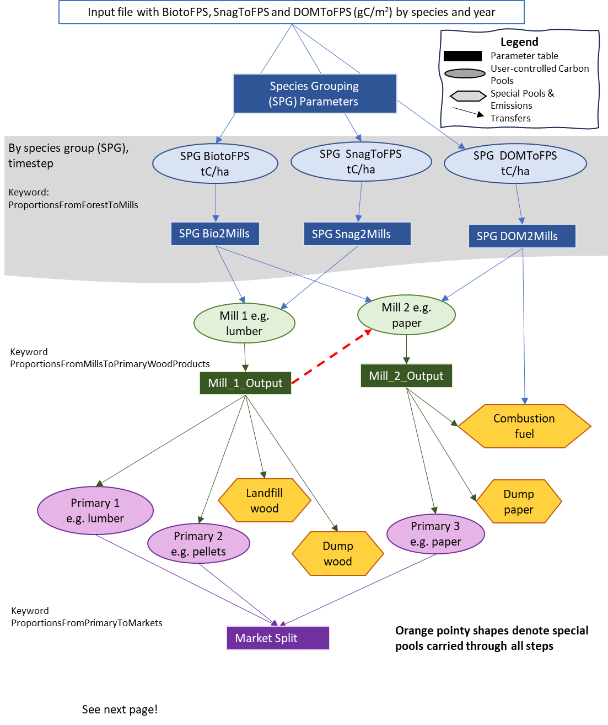

Figure 1: From forests to markets. Schematic of an example of how the first part of the Forest Products Sector Module can be used. Orange shapes with points on either side denote special pre-defined pools carried through all steps. See Section 2 for more information on keywords. The model schematic continues in Figure 2.

The first step of the FPSM is to read the output provided by ForCS or similarly formatted input from the user (Figure 1, Section 4). The module reads two CSV-formatted text files which respectively contain the amount of harvested live biomass over time, and harvest of snags and dead organic matter (DOM), by species. The code calculates the sum of harvested carbon in each “ToFPS” pool by timestep and species. The user can group these species into units that are most likely processed together, depending on their needs. For example, a group “All” could be created, which encompasses all species; or two groups “Hardwood” and “Softwood” could be created, to model the two kinds of wood products separately.

Note: In future versions, users will be able to provide the model with a management unit map so that this first processing step can include a dependence on location.

The processing of the harvest is defined in a table in which the user states, for each species group and harvest type, how the C is divided into different products. Users can define any number of different products, and both the destination mills and the proportions that go into each kind of mill, can change over time.

Mills to Primary Wood Products

At the end of the previous step, the C had been transferred to user-defined mills. In this step, the user defines what happens in each of these mills: how the C is processed into primary products such as lumber, chips, and panels. The user must create at least one destination for the carbon in each mill that was defined in the previous step.

One feature of this step is the ability to simulate one mill sending material to another mill to simulate chips going from a plywood mill to a paper mill, for example.

Primary Products to Markets

The module then provides the opportunity to simulate the movement of primary wood products to different markets. The notion of “market” can be defined in any way the user wishes, whether it is by province, state, region, country, or not relevant. The parameters for most later processing steps are stratified by market, so it makes sense to define the market at the level at which there are differences in processing or storage, or at the level at which reporting is important. For example, if one region mostly processes lumber into building material, and another into pallets, the regional difference is important. Alternatively, if regions process identically, but tracking needs to account for regional processes, then regions should also be used. However, markets do not affect landfill and dump parameters in this version of the FPSM.

Primary Products to Secondary Products

There are two steps to setting up the transfer from Primary to Secondary products. The first step is much like the previous step where Harvest was transferred to Primary Products. In this step, Primary products are divided into Secondary products by defining transfer parameters by time, and by Primary product (Figure 2). Because the previous step added the primary products to different markets, the parameters defining the proportions of primary products going into different secondary products can be further refined by market.

The second part of this step defines the rate at which these secondary products retire out of the product pool over time. To do this, FPSM uses decay/retirement functions with parameters provided by the user. These functions are:

- Instant, no parameters (e.g., for fuel)
- Exponential, with 1 parameter defining the half-life

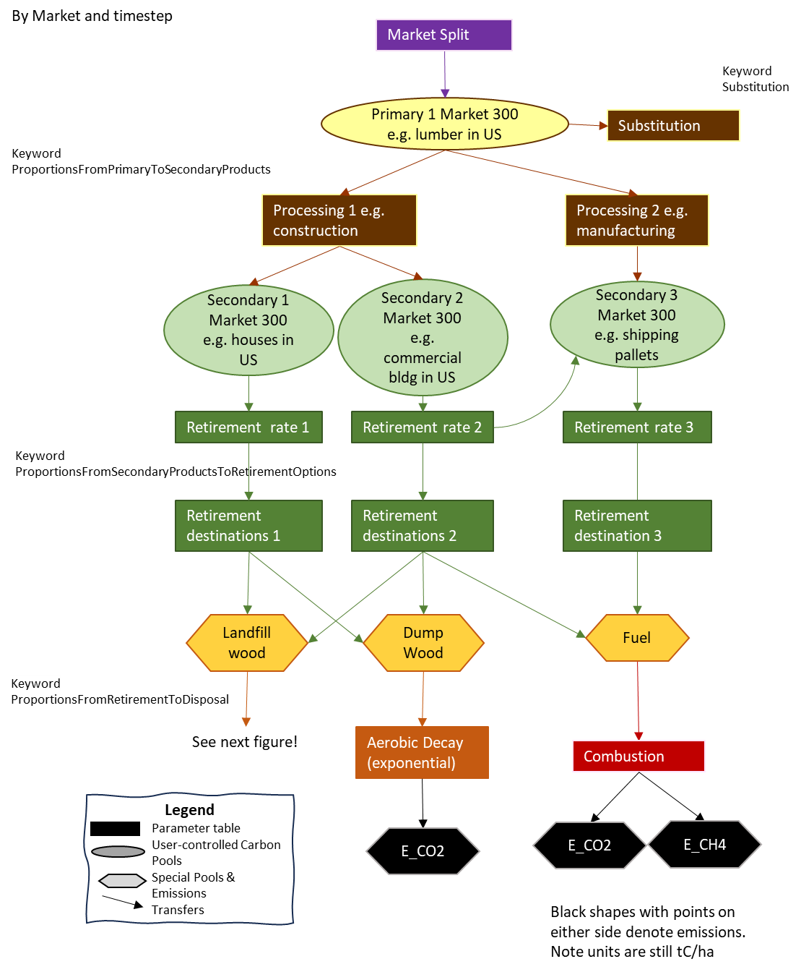
Figure 2: From market split to disposal including substitution, aerobic decay and combustion. Schematic of an example of application of the second part of the Forest Products Sector Module. Orange shapes with points on either side denote special pre-defined pools carried through all steps and do not vary by market. Black shapes denote emissions although they are tracked cumulatively like another pool. Model schematic continues in Fig 1 and 3. Output units are tC/ha.

Secondary Product Retirement

The previous step defined how C is removed from the secondary products pools using the given retirement function and parameters. This step defines where the C ends up once leaving the product pool and entering disposal pool (s).

The table is much like the others. Proportions are defined for each combination of market, product and destination. Note that recycling is an option here since a secondary product can become the same or another secondary product.

Also note that the disposal pools are all predefined special pools with codes 1000 and above. Users can define the input proportions, and whether or not they use a pool, but not how they are processed. A list of these definitions is in Table 1.

Table 1. Special predefined pools and codes.

Fixed Code | Description  (can be changed by user) | Comment
1000 | LandfillWood | Will be split into degradable and non-degradable components.
1001 | DumpWood | Used for aerobic decay.
1002 | CombustionFuel | Used for burning and bioenergy in forest sector.
1003 | DumpPaper | Used for aerobic decay.
1004 | LandfillPaper | Will be split into degradable and non-degradable components.
1005 | Fuel | Used for burning and bioenergy outside of forest sector.
1009 | DegradeableLandfillWood | The amount of Landfill Wood that is subject to decay.
1010 | DegradeableLandfillPaper | The amount of Landfill Paper that is subject to decay.
1500 | Anaerobic | Anaerobic decay pathway.
1511 | Aerobic | Aerobic decay pathway.
2006 | E_CO2 | End point emissions in the form of CO₂.
2007 | E_CH4 | End point emissions in the form of CH₄.
2008 | PotentialCH4 | CH₄ produced through anaerobic decay that, depending on model configuration may be released as an end point emission or may be treated by landfill gas management and oxidation.

Disposal

At the end of the previous step, the C is mostly in special pools such as fuel, dumps, or landfills (Figure 3). Because there are different pathways for the carbon that are all handled in one table, this is the most complicated table to understand and to parameterize.

There are three different options for what happens to these special pools (Table 1).

- The pool immediately and entirely transforms to gasses. Examples of this would be for fuel or combustible fuel. The definition for this case is like most of the other tables: the destination gas, and the proportion of the material that goes to the gas.

- The entire pool follows anaerobic or aerobic decay. An example would be DumpPaper or DumpWood. In this case, only the type of decay and the half-life of the pool are defined by the user.

- The pool is partially decayed and partially transferred to another pool. In this case, the user will define the proportion that goes to the other pool as well as the decay type and half-life that new pool. For example, LandfillWood will in part go to a degradable landfill wood pool. This pool will then decay using anaerobic decay with a half-life.

Respiration Rules & Landfill Gas Management

There are two predefined sets of respiration rules. Users should note that the FPSM does not currently recognize market-specific respiration, and the respiration rules are applied identically across all markets. To accommodate market differences users may have to weight respiration parameters based on the data available to their market context and the possible of mix of landfills with and without LFGM.

- Aerobic (1500)
  - The portion of DumpWood and DumpPaper that is decayed goes to E_CO2.
- Anaerobic (1511)
  - When the LandfillWood and LandfillPaper pools decay, 50% goes to E_CO2 and 50% to PotentialCH4.
  - Users must define the oxidation efficiency, which represents the proportion of PotentialCH4 that is converted to CO₂ as it passes through the landfill cap. An oxidation efficiency of 1.0 will convert 100% of potential CH₄ to CO₂.
  - Besides defining the oxidation efficiency, users can further define the fate of intermediate methane as it is handled by landfill gas management systems. The model then calculates the final emissions as:
    - E_CO2 = 50% of anaerobic decay +
PotentialCH4 * ProportionofLandfillsWithLGM * CaptureEfficiency +
(PotentialCH4 – (PotentialCH4 * ProportionofLandfillsWithLGM * CaptureEfficiency) * Oxidation)
    - E_CH4 = the remainder.

Note: The three variables E_CO2, PotentialCH4 and E_CH4 shown above all represent units of tC/ha and not the molecular mass (e.g., tCO₂/ha, tCH₄/ha) which their names may suggest.

Substitution

Substitution does not affect the distribution of C in pools. It is a basic calculation to provide a sense of the substitution effects, i.e. the CO₂e benefit if the total harvest was used instead of higher global warming potential products.

For each market and primary product, users can define two values: a substitution ratio and a displacement factor. The ratio represents the proportion of the market where consumers are using wood to replace higher Global Warming Potential products. The typical Life Cycle Assessment or mitigation study assumes 1.0. The displacement factor is the impact of the use of wood instead of other products. The total substitution impact is calculated as:

C in PrimaryPool * SubstitutionRatio * DisplacementFactor

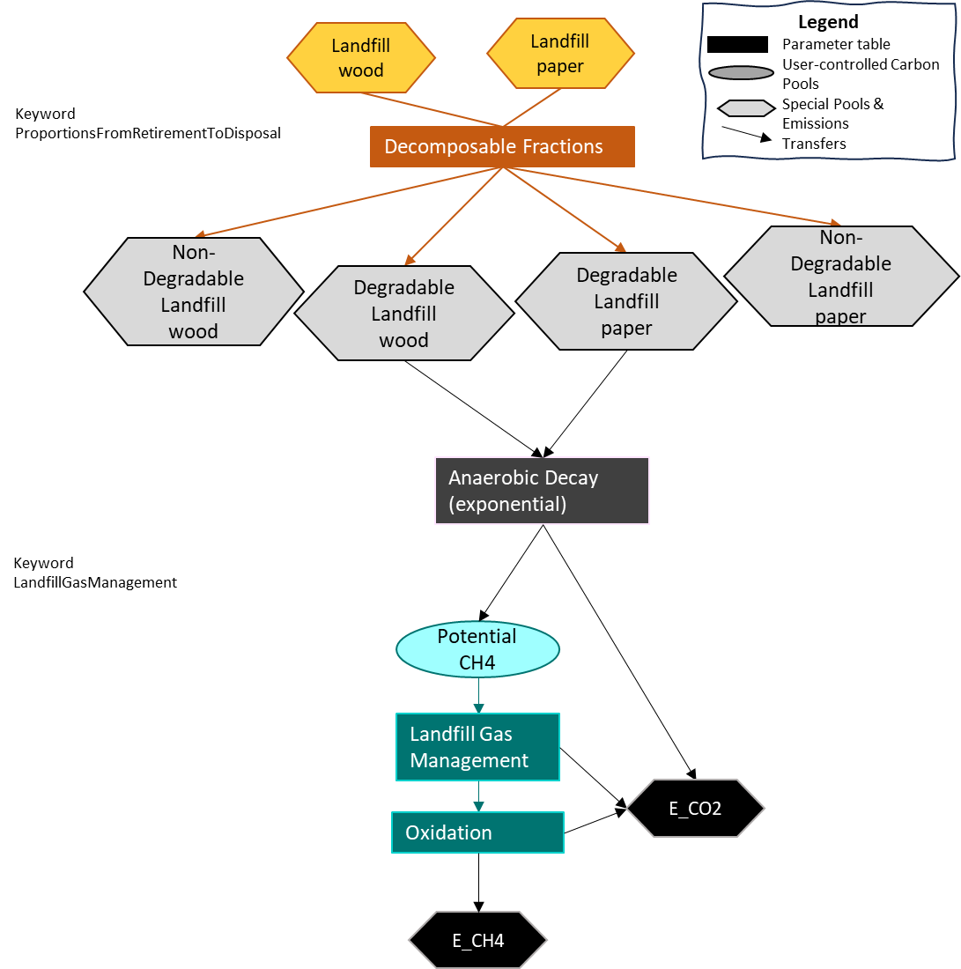

Figure 3. Landfill emissions. Schematic of the third part of the Forest Products Sector Output extension. Orange shapes with points on either side denote special pre-defined pools carried through all steps and do not vary by market. Black shapes denote emissions although they are tracked cumulatively like another pool. Model schematic continues from Figure 2. Output units are tC/ha.

References

Dymond, C.C., 2012. Forest carbon in North America: annual storage and emissions from British Columbia’s harvest, 1965–2065. Carbon Balance and Management, 7(1):1-20. https://doi.org/10.1186/1750-0680-7-8

Dymond, C.C., Beukema, S, and Scheller, R.M. 2021. Landis-II Forest Carbon Succession Extension Version 3.1. 36 p. https://github.com/LANDIS-II-Foundation/Extension-ForCS-Succession/blob/master/docs/LANDIS-II%20ForC%20Succession%20v3.1%20User%20Guide.pdf

Marland, E.S., Stellar, K. and Marland, G.H., 2010. A distributed approach to accounting for carbon in wood products. Mitigation and Adaptation Strategies for Global Change, 15: 71-91. https://doi.org/10.1007/s11027-009-9205-6

Acknowledgments

Funding was provided by the British Columbia Ministry of Forests.

Main Input Configuration File

This section describes in detail each of the tables and parameters the user must define. An example is provided in Section 3. Nearly all the input parameters for this extension are specified in one main input file. This text file must comply with the general format requirements described in Section 3.1 Text Input Files in the LANDIS-II Model User Guide found here:

https://drive.google.com/file/d/1FliLjtmLKD_D4uAfo9d_VMs_6jRkOcNh/view.

Note that the “Name” column is provided to make the table more readable for humans, and any codes>1000 are pre-defined as they have specific processing steps.

TimeStart – the first column indicates when the parameters in the row should start being used. They will continue to be used until a new TimeStart is provided. This allows dynamic parameterization.

Header

LandisData | This parameter’s value must be "FPS".
CellLength | The length in meters of a square simulation cell (pixel). Used to convert to tC/ha absolute value from gC/m2 input default. The module converts the units using the cell size input variable and should represent ¼ of the perimeter of a row in the input file, i.e. 100 m for a hectare cell. If the user doesn’t want the units to change, simply set the CellLength to 1. Note the denominator only considers harvested area and not a landscape average.
YearsPostHarvest | The number of years past the last harvest in the input file to simulate. Value: >0. Units: years.

Input Files

HarvestFileLive | .csv filename containing harvested biomass carbon, see Section 4.
HarvestFileDOM | .csv filename containing harvested dead organic matter carbon, see Section 4.
ManagementUnits | Not functional in this version of FPSM
OutputInterval | How frequently the output will be written. Minimum 1, must be integer.

Species Group Table

The keyword “SpeciesGroupTable” must be prior to the table. This table is used to read input information and assign species to different groups that can be sent to different mills and products later on.

Species | The list of the species from the input files.
Group | An integer defining group membership. >1 and <1000. Use the code 99 to mean all species. (We’ve not tested with more than 3 groups).
Group Name | A name for the group.

Forest to Mills

This table contains the information about dividing up the harvest to different primary mills. The keyword “ProportionsFromForestToMills” must be prior to the table.

Time Start | The first timestep of the model run when these parameters must be applied. Value: >0. Units: years.
Unit Code | The management unit code is a placeholder for future development and is not currently functional.
Species Group | Code from Species Group Table.
Pool | Must be one of BioToFPS, SnagToFPS or DOMToFPS and align with column heading in input file.
Mill Code | Mills and other facilities that take in harvested fibre to create products. User defined unique integer >1 and <1000 or special pool code (Table 1).
Mill Name | User defined name.
Multiplier | User defined proportions that indicate how much of the carbon from the Species Group X Pool combination should end up in each Mill Code pool.

Mill To Primary

This table contains the information about how mills create primary products and dispose of their waste. The keyword “ProportionsFromMillsToPrimaryWoodProducts” must be prior to the table. Proportions must sum to 1 for combinations of time and mill.

Time Start | The first timestep of the model run when these parameters must be applied. Value: >0. Units: years.
Mill Code (From) | Defined in the previous table.
Mill Name (From) | Defined in the previous table.
Primary Code (To) | Products and waste disposal created from manufacturing using harvested fibre. User unique defined integer >1 and <1000 or special pool code (Table 1).
Primary Name (To) | User defined name.
Mill multiplier | Proportion of incoming pool (defined by the Mill Code) that will end up as the product or disposal pool (defined by Primary Code).

Primary Products to Markets

This table gives the proportions of how primary products are divided into different markets so that different parameter sets can be applied below. The keyword “ProportionsFromPrimaryToMarkets” must be prior to the table. Proportions must sum to 1.0 for time, output code combinations.

Time Start | The first timestep of the model run when these parameters must be applied. Value: >0. Units: years.
Primary Code (From) | Defined in the previous table.
Primary Name (From) | Defined in the previous table.
Market Code (To) | User unique defined integer >1 and <1000.
Market Name (To) | User defined name.
Market multiplier | Proportion of incoming pool that will be split among the different markets.

Primary to Secondary

This table gives the proportions that define how primary products are divided into secondary products and the retirement rate. This is the stage where products are stored while they are in use, and then are gradually retired out of use or disposed of. The keyword “ProportionsFromPrimaryToSecondaryProducts” must be prior to the table. Proportions must sum to 1.0 for the combination of time, market and primary codes. If users are following the IPCC default method, primary and secondary products are the same.

Time Start | The first timestep of the model run when these parameters must be applied. Value: >0. Units: years.
Market Code (From) | Defined in the previous table.
Primary Code (From) | Defined in the previous table.
Primary Name (From) | Defined in the previous table.
Secondary Code (To) | Products made from primary products and the resulting manufacturing and construction waste. User unique defined integer >1 and <1000 or special pool code (Table 1).
Secondary Name (To) | User defined name.
Secondary X | Proportion of the primary product pool (not including special pools) that will be transferred to the secondary pool.
Retirement Function | Function that will be applied to reduce secondary output pools annually. Only ‘exponential’ and ‘instant’ are accepted.
Parameter 1 | Value to be used in the retirement function. For exponential it should be the integer half-life. For instant it should be –99. Value: >0. Units: years.
Parameter 2 | Not currently used. Planned for gamma distribution functionality.

Secondary to Retirement

Once the exponential decay curve is applied to the secondary product pool, the amount removed from the pool is handled according to this table. The remainder stays in the secondary product pool until the next timestep. This table gives the proportions of how retired carbon from the secondary products are handled when they are disposed of or recycled. The keyword “ProportionsFromSecondaryProductsToRetirementOptions.” must be prior to the table. Proportions must sum to 1.0 for each time, market, secondary combination. For modelling where storage and landfills are not considered, send all carbon to 1005 (Fuel) for instantaneous oxidation.

Time Start | The first timestep of the model run when these parameters must be applied. Value: >0. Units: years.
Market Code (From) | Defined in the previous table.
Secondary Code (From) | Defined in the previous table.
Secondary Name (From) | Defined in the previous table.
Retirement Code (To) | The pool where carbon from the secondary products will go when the product is recycled or disposed of. Options include Secondary Output Codes or Special codes (Table 1).
Retirement Name (To) | User defined name.
Retirement multiplier | Proportion of the secondary product pool that will be transferred to the retirement pool.

Disposal

Two tables are used to specify disposal parameters. The first table is shown below in 3 parts for clarity: each representing the details for disposal under conditions of combustion, aerobic and anaerobic decay. Valid respiration codes are: 1511 (Aerobic), 1500 (Anaerobic). Codes 2999 and –99 are N/A and are used for combustion. The second table (Section 0) shows how methane is handled. The keyword “ProportionsFromRetirementToDisposal” must be prior to the table.
Proportions must sum to 1.0 for each time, retirement code combination.

Combustion
Time Start: | The first timestep of the model run when these parameters must be applied. Value: >0. Units: years.
Retirement Code (From) | 1002 or 1005
Retirement Name (From) | Defined in the previous table.
Disposal Code (To) | 2006 or 2007
Disposal Name (To) | E_CO2 or E_CH4.
Disposal X | Proportion of pool 1002 or 1005 that will be transferred to the Disposal Code pools. For combustion (instantaneous oxidation) the proportion should be set to 1.0 for 2006.
Half-life | –99
Respiration Code | –99
Respiration Name | N/A

Aerobic Decay
Time Start | The first timestep of the model run when these parameters must be applied. Value: >0. Units: years.
Retirement Code (From) | 1001 or 1003
Retirement Name (From) | Defined in the previous table.
Disposal Code (To) | 2999
Disposal Name (To) | N/A
Disposal X | 1 (Other values not tested)
Half-life | The half-life applies to 100% of the 1001 or 1003 pool as defined by the Disposal X. It will be used in the exponential decay equation. Note that the amount decayed will be transferred to pool 2006 (E_CO2). The rest will remain in 1001 or 1003.
Respiration Code | 1511
Respiration Name | Aerobic

Anaerobic
Time Start: | The first timestep of the model run when these parameters must be applied. Value: >0. Units: years.
Retirement Code (From) | 1000 or 1004
Retirement Name (From) | Defined in the previous table.
Disposal Code (To) | 1009 or 1010
Disposal Name (To) | DegradableLandfillWood or DegradableLandfillPaper
Disposal X | The proportion of pool 1000 or 1004 that will be transferred to pools 1009 or 1010 because that carbon can decay.
Half-life | The half-life to be used in the exponential decay equation and applied to pool 1009 or 1010. Note that the amount decayed will be transferred to 50% to pool 2006 (E_CO2) and 50% to pool 2008 (Potential CH4). See the table LandfillGasManagement for further parameterization.
Respiration Code | 1500
Respiration Name | Anaerobic

Substitution

This table gives information about how to calculate substitution effects. Substitution effects are based on the Primary products. Even if you are not using this functionality there must be at least one line of parameters. The keyword “Subsitution” must be prior to the table. There’s no requirement that proportions sum to 1.0 but products not included in this table will not have a substitution effect.

Time Start | The first timestep of the model run when these parameters must be applied. Value: >0. Units: years.
Market Code | Defined above.
Primary Code | Defined above.
Primary Name | Defined above.
Substitution Ratio | The proportion of the market where consumers are using wood to replace higher Global Warming Potential products. The typical Life Cycle Assessment or mitigation study assumes 1.0.
Displacement Factor | The displacement factor is the impact of the use of wood instead of other products (tC/tC).

Landfill Gas Management

This is the second table defining end-of-life parameters. This table gives information about how to calculate methane emissions including landfill gas management (LFGM). The values in this table are only used if Respiration Code 1500 (anaerobic decay) is used. If there is no LFGM, set the Landfills With LFGM X and Capture Efficiency parameters to –999 and set the Oxidation rate appropriately. Note that, unlike most other tables, there can only be one line of input per year. Even if you are not using this functionality there must be at least one line of parameters.
The keyword “LandfillGasManagement” must be prior to the table.

Time Start | The first timestep of the model run when these parameters must be applied. Value: >0. Units: years.
Respiration Code | Defined above.
Landfills With LFGM | Proportion of the wood and paper in landfills that have LFGM.
Capture Efficiency | Proportion of the methane produced from the decay of wood and paper that will be taken up by the LFGM system and converted into CO₂. Note this combines several steps that occur in more sophisticated landfill models so users may need to do some calculations for parameterization.
Oxidation | Proportion of the methane produced from the decay of wood and paper that will not be taken up by the LFGM but will be converted into CO₂ by the cap on the landfill.

Sample Main Input File Example Tier 1 IPCC production approach with simple decay of commodity classes

Note: Lines beginning with “>>” are treated as comments.

>> Tables formatted in Notepadd++ v8.5.4
>> Example Tier 1 IPCC production approach with simple decay of commodity classes
LandisData "FPS"

>> Length of cell side in m, used to convert m2 values to totals, should be the same as in ForCS run. Set to 1 for no unit conversion.
CellLength 100

>> Number of years past the last harvest to simulate
YearsPostHarvest 10

HarvestFileLive "log_FluxBio.csv"
HarvestFileDOM "log_fluxDOM.csv"
ManagementUnits "manunits.gis"

OutputInterval 1

SpeciesGroupTable
>>Group: up to 2. Use word "all" to mean all species
>> all 99 ALL
>>Species Group GroupName
>>----------------------------------------------
all 99 all

ProportionsFromForestToMills

>> Time Unit Species Pool Mill Code Mill Name
>> Start Code Group (From) (To) (To) Multiplier
>>-------------------------------------------------------------------------------------------------------------------------------------------------------------------------------------------------------------------------
0 1 99 BioToFPS 1 SawnwoodMill 0.5
0 1 99 BioToFPS 2 WoodbasedPanelsMill 0.25
0 1 99 BioToFPS 3 Chipmill 0.25
0 1 99 SnagToFPS 1 SawnwoodMill 0.2
0 1 99 SnagToFPS 2 WoodbasedPanelsMill 0.0
0 1 99 SnagToFPS 3 Chipmill 0.8

ProportionsFromMillsToPrimaryWoodProducts
>> Time Mill Code Mill Name Primary Primary Multiplier
>> Start (From) (From) Code (To) Name (To)
>>--------------------------------------------------------------------------------------------------------------------------------------------------------------

0 1 SawnwoodMill 104 Sawnwood 0.5
0 1 SawnwoodMill 1002 InstantEmission 0.5
0 2 WoodbasedPanelsMill 106 Panels 0.5
0 2 WoodbasedPanelsMill 1002 InstantEmission 0.5
0 3 Chipmill 105 Chips 0.7
0 3 Chipmill 1002 InstantEmission 0.3

ProportionsFromPrimaryToMarkets
>> Time Primary Primary Market Market Name Multiplier
>> Start Code (From) Name (From) (To) (To)
>>---------------------------------------------------------------------------------------------------------------------------------------------------------------------------------------------------------------------------------------------------------
0 105 Chips 300 Global 1
0 104 Sawnwood 300 Global 1
0 106 Panels 300 Global 1

ProportionsFromPrimaryToSecondaryProducts
>>Time Market Primary Primary Secondary Secondary Secondary Retirement Param. 1 Param. 2
>>Start Code (From) Code (From) Name (From) Code (To) Name (To) Multiplier function
>>---------------------------------------------------------------------------------------------------------------------------------------------------------------------------------------------------------------------------------------------
0 300 105 Chips 200 PaperPackaging 1 exponential 2 -99
0 300 104 Sawnwood 204 Sawnwood 1 exponential 35 -99
0 300 106 Panels 209 Panels 1 exponential 25 -99

ProportionsFromSecondaryProductsToRetirementOptions
>> Time Market Secondary Secondary Retirement Retirement Retirement
>> Start Code (From) Code(From) Name (From) Code(To) Name(To) Multiplier
>>---------------------------------------------------------------------------------------------------------------------------------------------------------------------------------------------------------------------------------------------------------
0 300 200 PaperPackaging 1002 InstantEmission 1
0 300 204 Sawnwood 1002 InstantEmission 1
0 300 209 Panels 1002 InstantEmission 1

ProportionsFromRetirementToDisposal
>>Time Retirement Retirement Disposal Disposal Disposal Half-life Respiration Respiration
>>Start Code (From) Name (From) Code(To) Name (To) Multiplier Code Name
>>---------------------------------------------------------------------------------------------------------------------------------------------------------------------------------------------------------------------------------------------
0 1002 InstantEmission 2006 E_CO2 1 -99 -99 NA

Substitution
>> Substitution = Primary * SubstitutionRatio * DisplacementFactor
>>Time Market Primary Primary Substitution Displacement
>>Start Code Name Ratio Factor
>>--------------------------------------------------------------------------------------------------------------------------------------------
>> 0 300 104 Sawnwood 0 0

LandfillGasManagement
>>TimeStart Respiration Landfills Capture Oxidation
>>Start Code With LFGM Efficiency
>>---------------------------------------------------------------------------------------------------------------------------------------------
0 1500 -999 -999 0.22

Input Files from FORCS

The FPSM requires input of living and dead biomass. When created by the LANDIS-II ForCS extension these data are retrieved from the filenames called:

- log_FluxBio.csv and
- log_FluxDOM.csv

The filenames are under user control via the Main Input Configuration file (see Section 0). The content of these two files must follow the format described in Section 7.5 and 7.6 of the ForCS documentation (Dymond et al. 2021) as summarized below in Table 2 and Table 3.

log_FluxBio.csv

The file log_FluxBio.csv has 17 columns that gives information about the rate of C transfer from the live biomass pools on each site after a disturbance in that timestep. The time, species and BioToFPS are read by the FPSM (highlighted). If you are not using ForCS, you must structure your FPSM input in this manner, but only the highlighted fields matter.

Table 2. Columns found in the log_FluxBio.csv input file.

Column | Title | Value | Units | Notes
1 | Time | Integer | – | Model timestep (annual)
2 | Row | Integer | – | Raster grid row
3 | Column | Integer | – | Raster grid column
4 | Ecoregion | Integer | – | ID based on order in ecoregions text file
5 | Species | Character | – | User defined name
6 | Dist | Integer | – | Disturbance ID: 1 – fire; 2 – harvest; 3 – wind; 4 – Biological Disturbance Agent (BDA)
7 | MERCH_ToDOM | Real | gC/m²/y | C transferred from merchantable to snags or other DOM pools
8 | MERCH_ToAir | Real | gC/m²/y | C released from merchantable live biomass to the air
9 | FOL_ToDOM | Real | gC/m²/y | C transferred from the foliage to DOM pools
10 | FOL_ToAir | Real | gC/m²/y | C released from foliage to the air
11 | OtherWoody_ToDOM | Real | gC/m²/y | C transferred from other live woody to DOM pools
12 | OtherWoody_ToAir | Real | gC/m²/y | C released from other live woody to air
13 | CrsRt_ToDOM | Real | gC/m²/y | C transferred from coarse root to DOM pools
14 | CrsRt_ToAir | Real | gC/m²/y | C released from coarse root to the air
15 | FRt_ToDOM | Real | gC/m²/y | C transferred from fine root to DOM pools
16 | FRt_ToAir | Real | gC/m²/y | C released from fine root to the air
17 | BioToFPS | Real | gC/m²/y | C transferred to the forest product sector (e.g., from harvest).

log_FluxDOM.csv

The file log_FluxDOM.csv has 20 columns that give information about the rate of C transfer from the DOM on each site after a disturbance in that timestep. The time, species SnagsToFPS and DOMToFPS are read by the FPSM.

Table 3. Columns found in the log_FluxDOM.csv input file.

Column | Title | Value | Units | Notes
1 | Time | Integer | – | Model timestep (annual)
2 | Row | Integer | – | Raster grid row
3 | Col | Integer | – | Raster grid column
4 | Ecoregion | Integer | – | ID based on order in ecoregions text file
5 | Species | Character | – | User defined name
6 | Dist | Integer | – | Disturbance ID: 1 – fire; 2 – harvest; 3 – wind; 4 – Biological Disturbance Agent (BDA)
7 | VF_A_toAir | Real | gC/m²/y | C released from the very fast aboveground pool to air
8 | VF_B_toAir | Real | gC/m²/y | C released from the very fast belowground pool to air
9 | Fast_A_toAir | Real | gC/m²/y | C released from the fast aboveground pool to air
10 | Fast_B_toAir | Real | gC/m²/y | C released release from the fast belowground pool to air
11 | MED_toAir | Real | gC/m²/y | C released from the medium pool to air
12 | Slow_A_toAir | Real | gC/m²/y | C released from the slow aboveground pool to air
13 | Slow_B_toAir | Real | gC/m²/y | C released from the slow belowground pool to air
14 | Sng_Stem_toAir | Real | gC/m²/y | C released from the snag stems pool to air
15 | SngStemToMed | Real | gC/m²/y | C transferred from the snag stems pool to the medium pool
16 | Sng_Oth_toAir | Real | gC/m²/y | C released from the snag other pool to air
17 | SngOthToFast | Real | gC/m²/y | C transferred from the snag other pool to the fast aboveground pool
18 | Extra_toAir | Real | gC/m²/y | C released of from the extra pool to air
19 | SnagsToFPS | Real | gC/m²/y | C lost from snag stem to the forest product sector
20 | DOMtoFPS | Real | gC/m²/y | C lost from of any other dead C to the forest product sector

Output

Three output files are produced. The first file lists any input errors that occur. The second file contains a list of all the transfers that are done in the first several steps of the process, and the third file contains amounts in the pools and emitted. In the future, FPSM will provide summary output.

FPS_log.txt

This text file reports any potential non-fatal errors that may be in the input files. These errors may be detected as the FPSM does internal checking to make sure that all proportions add to 1, and that all values are assigned to defined pools. For example, errors might report that:

- Proportions do not add to 1 for pool x, or
- No substitution factors found for year: 1, market: 301, product: 105

In an ideal, well-parameterized run, this file will be empty.

This file could be empty, or it could have some minimal reporting such as:

No substitution factors found for year: 1, market: 300, product: 105
No substitution factors found for year: 1, market: 301, product: 105
No substitution factors found for year: 2, market: 300, product: 105

FPS_test_out.csv

This file contains 5 comma-separated fields and reports fluxes between pools as they happen, to help with error checking and debugging. Carbon units are expressed as tC/ha.

Table 4. Fields of the FPSM output file FPS_test_out.csv
Column | Title | Value | Units | Notes
1 | Step | Integer | – | 1 – Harvest to Mill transfers;  2 – Mill to Primary transfers;  3 – Primary to Market transfers;  4 – Primary to Secondary transfers;  5 – Secondary to Retirement transfers;  6 & 7 – not used;  8 – Substitution amounts;  9 – Retirement (buggy, not recommended)
2 | Year | Integer | Year | Model timestep being reported.
3 | Market | Integer | – | Market code defined by the input configuration (–99 when a market code has not been defined).
4 | Pool | Integer | – | Destination pool code defined by the input configuration file.
5 | Amount | Real | tC/ha | C transferred into the destination pool.

Table 5. A few lines of the FPS_test_out.csv output file showing a sample output of carbon transfers. These are essential for quality control by the users.

Step | Year | Market | Pool | Amount
1 | 1 | -99 | 2 | 30777
2 | 1 | -99 | 104 | 75299
2 | 1 | -99 | 105 | 41826
2 | 1 | -99 | 1000 | 15059
3 | 1 | 300 | 104 | 15059
3 | 1 | 301 | 104 | 6023
3 | 1 | 300 | 105 | 20913
3 | 1 | 301 | 105 | 20913
3 | 1 | -99 | 1000 | 15059
1 | 2 | -99 | 1 | 1503
1 | 2 | -99 | 2 | 6678
2 | 2 | -99 | 104 | 13255

FPS_raw_out.csv

This file contains eight comma-separated fields and provides detailed listing of transfers from the final stages of the processing. Having the year created field allows users to track emission estimates back to the harvest year. This is essential for users to do quality control on their models. Carbon units are expressed as tC/ha.

Table 6. Fields of the FPSM output file FPS_raw_out.csv

Column | Title |  | Value | Units | Notes
1 | Type  (for debugging can be ignored by most users) |  | Integer | – | 1-3 – ID denoting transfer from a Retirement Pool to Disposal: 1-3 – debugging codes that can be ignored by most users; 4 – amount remaining in the special pool at the end of the simulation year; 5 – amount remaining in the secondary product pool at the end of the simulation year after some has been retired to a landfill or fuel
2 | YearCreated |  | Integer | Years | Simulation year in which the From Pool was created, e.g., the harvest year
3 | YearReported |  | Integer | Years | Simulation year in which the emission takes place, or the pool amount is reported; the year of the simulation, not the year since creation
4 | Market |  | Integer | – | Market code defined by the input configuration file. Pools that do not have a Market number by design are assigned a zero.
5 | FromPool |  | Integer | – | Code of the starting (source) pool
6 | To_Gas/Pool |  | Integer | – | Code of the ending (destination) pool or emitted gas
7 | AmountEmitted |  | Real | tC/ha | C transferred from the source to the destination pool
8 | AmountRetained |  | Real | tC/ha | C retained in the destination pool at the end of the year

Table 7. A few lines of the FPS_raw_out.csv output file showing in part how some of the different types of output are reported. Notice that reports are either emitted or retained, and that amounts retained have the same from and to pools.

Type | Year  Created | Year  Reported | Market | From  Pool | To_Gas/  Pool | Amount  Emitted | Amount  Retained
4 | 1 | 5 | 0 | 1001 | 1001 | 0 | 1821.59
5 | 1 | 5 | 300 | 205 | 205 | 0 | 28.17
4 | 2 | 5 | 0 | 1000 | 1000 | 0 | 1550.12
4 | 2 | 5 | 0 | 1001 | 1001 | 0 | 349.48
4 | 3 | 5 | 0 | 1009 | 1009 | 0 | 470.57
3 | 5 | 5 | 0 | 1002 | 2006 | 12211.69 | 0
3 | 5 | 5 | 0 | 1002 | 2007 | 0.0183 | 0

